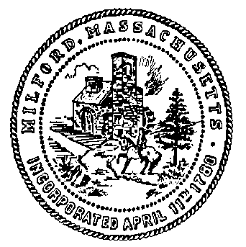
Town Clerk’s Office
Town Hall Room 12
52 Main Street • Milford, MA 01757
Ph: (508) 634-2307 • Fax: (508) 634-2324
aneves@townofmilford.com
Amy E. Hennessy Neves, Town Clerk

FROM: Town Meeting Working Group (TMWG)
TO: Town Meeting Members (TMM)
RE: Survey to Obtain Feedback about Town Meeting Procedures from All Town Meeting Members

For those who did not hear Reno DeLuzio’s presentation about the TMWG at Town Meeting last October; the TMWG has been formed to examine and evaluate current Town Meeting operating procedures compared to those of other towns and examine feedback we will gain from current Town Meeting Members.
We have completed our review of numerous other town procedures---now we need your feedback. We really need your thoughts and honest opinions and you can voice them through this survey.
- The survey will be sent to you in a few days.
- TM Members who provided an email address will receive an email with a link to do the survey online which then will be immediately available to the survey consulting company we are working with.
- Those who did not provide an email address to the Town Clerk will receive paper surveys via regular mail with return envelopes.
- Both methods of completing the survey are anonymous.
- A report from the survey company will provide overall results and their interpretation of the data.
When your survey arrives by email or postal mail, please fill it out and return it in as soon as possible. We’d prefer you complete it within a week but please by March 22nd the very latest. The survey will provide an email to send the response back to but those who were mailed this letter and the survey will have to print out their survey and return it with the envelope provided.
It’s important we have everyone’s feedback.
This is your opportunity to help improve town meeting and our participation in it. Now is your chance to have your voice heard! Please note that we have sent this letter to all current Town Meeting Members either by email or by Postal mail. We are doing our best to conserve the Town’s budget, so if we do not already have your email please provide your email to the Town Clerk’s Office by sending it to the Town Clerk’s email (aneves@townofmilford.com). Thank you.
Regards,
Town Meeting Working Group
(Town Meeting Working Group (TMWG) is made up of 1 volunteer from each precinct, 3 members appointed by the Board of Selectmen and 3 members from Citizens for Milford)

